EXP NO 3: CREATE A SIMPLE CLOUD SOFTWARE APPLICATION FOR PROPERTY BUYING & RENTAL PROCESS (IN CHENNAI CITY) USING ANY CLOUD SERVICE PROVIDER TO DEMONSTRATE SAAS.

AIM: To Create a simple cloud software application for Property Buying & Rental process (In Chennai city) using any Cloud Service Provider to demonstrate SaaS.

PROCEDURE:
Step1: Go To Zoho.Com.
Step 2: Log Into The Zoho.Com.
Step 3: Select One Application Step.
Step4: Enter Application Name As Property Buying & Rental.
Step 5: Created New Application As Property Buying & Rental.
Step 6: Select One Form Step 7: The Software Has Been Created.

IMPLEMENTATION:
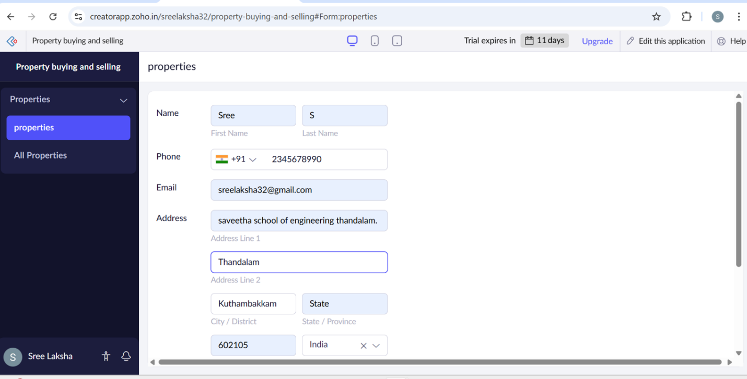
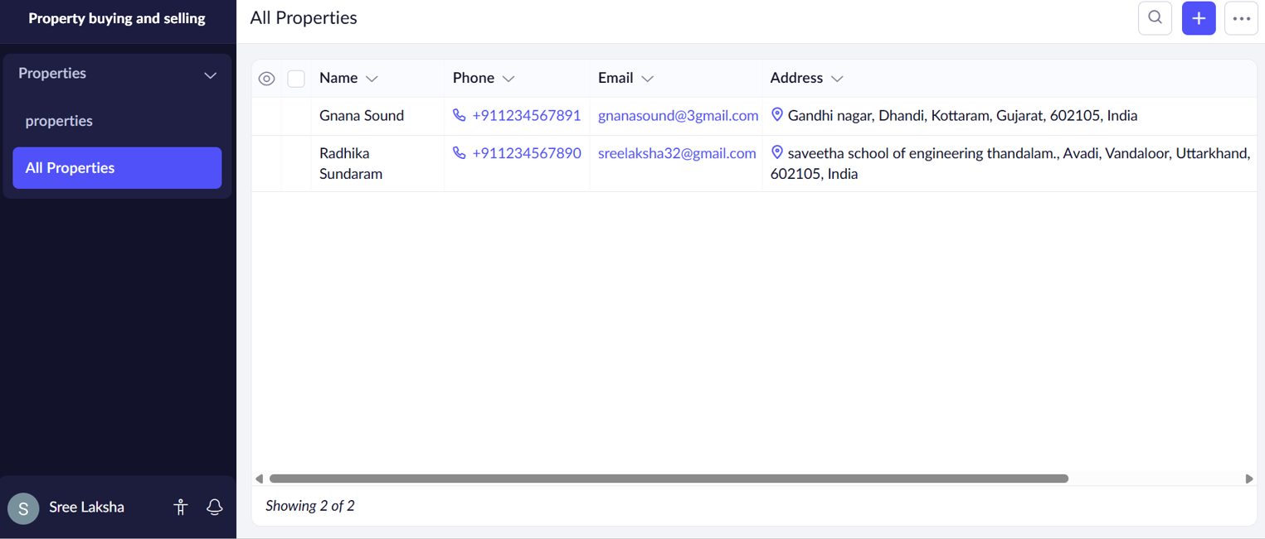
OUTPUT:

RESULT:
Thus a simple cloud software application for property buying and rental process( in Chennai city) was done successfully.

